CREATIYOK Post-Project Evaluation Survey
Partners Completed also this Post Project Evaluation Survey on our Final Meeting of the Project in Poland on 20 of August
The purpose of this survey is to evaluate the overall project and the activities carried out within it. Through your feedback, we aim to:
- assess the quality and effectiveness of project management, trainings, meetings, and outputs,
- understand the impact of the activities on your professional development and on the target groups,
- identify strengths, challenges, and areas for improvement,
- gather recommendations to enhance the design and implementation of future projects.
Your honest reflections will be highly valuable for improving our work and ensuring the sustainability of similar initiatives in the future.
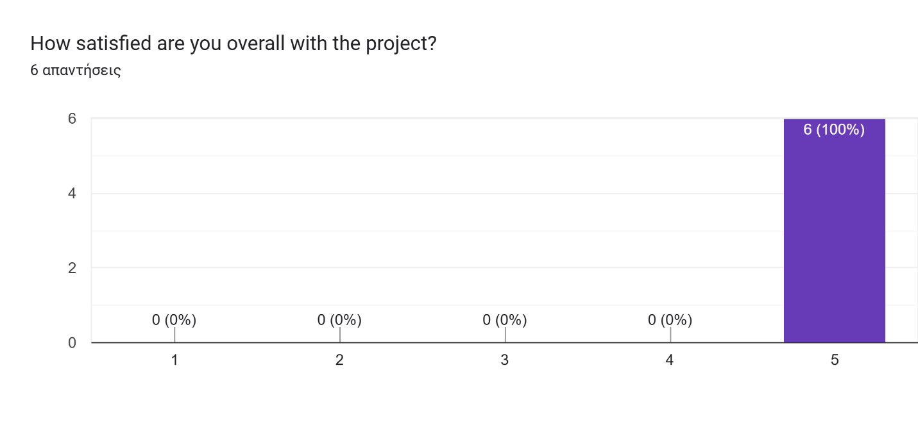
What did you personally gain from participating in this project?
- As part of the project, I learned to better understand the structure of KA2 projects and work with an international team. Our organization also gained experience in art therapy and started using additional tools in working with youth. Eight youth workers participated in the training, and dozens of young people were able to take part in events from the project.
- I broke down communication barriers and improved my group work
- New youth work methods, organisational skills and network
- This project gave me the chance to grow as a youth worker and team facilitator. I learned how to use creative arts in workshops and how powerful they can be for self-expression and inclusion. Personally, I gained more confidence in leading activities, communicating with international teams, and supporting young people in their learning journey. It also inspired me to bring more creativity into my everyday work and to keep experimenting with new methods.
- Lots of experience in prject managemnet and even better understanding of the programme
- Participating in this project enriched me both professionally and personally. I deepened my understanding of how creative arts can be applied as effective non-formal education tools for youth empowerment and inclusion. As a project manager with long experience, I gained fresh perspectives from international colleagues, which allowed me to refine methodologies and integrate new approaches into our organization’s long-term strategy. The exchange also strengthened my leadership and mentoring role, ensuring I can better guide young people and youth workers in future initiatives.
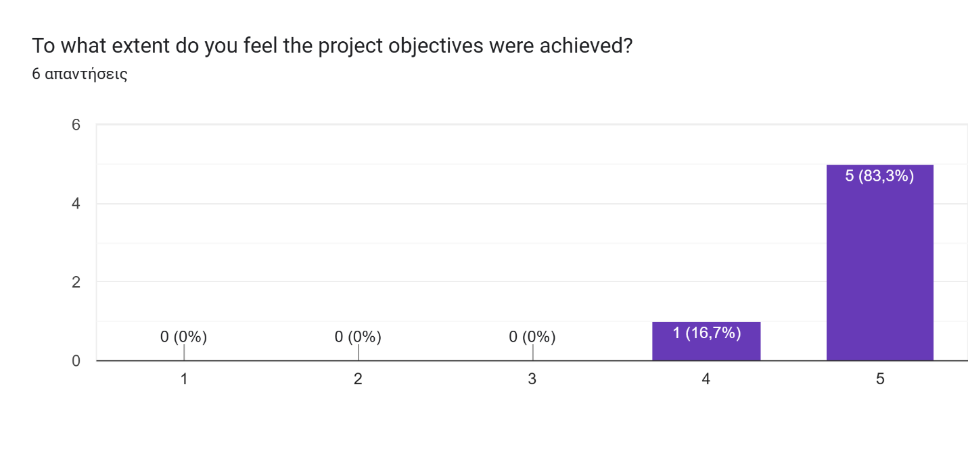
What aspects of the project should be improved in the future?
- From the organizers' side, everything was perfect—communication, adaptability, support—thank you for the quality work.
- maybe more artistic elements
- I would change nothing
- For me, the project worked really well, but I think we could improve by making the activities even more interactive and youth-led. I would also suggest using more digital tools to keep the participants connected after the project ends, so the learning and teamwork can continue beyond the official activities.
- Maybe better planned communication between organisations to avoid misunderstandings
- While the project was highly successful, there are always areas for improvement. In the future, I believe we should invest more in strengthening the follow-up phase to ensure the long-term use of project results by local communities. Additionally, allocating more structured time for reflection and evaluation during the international trainings would allow participants to better consolidate their learning. Finally, enhancing collaboration with policymakers and local stakeholders could help embed the project’s methodologies into broader youth strategies.

Activity 1: Project Management
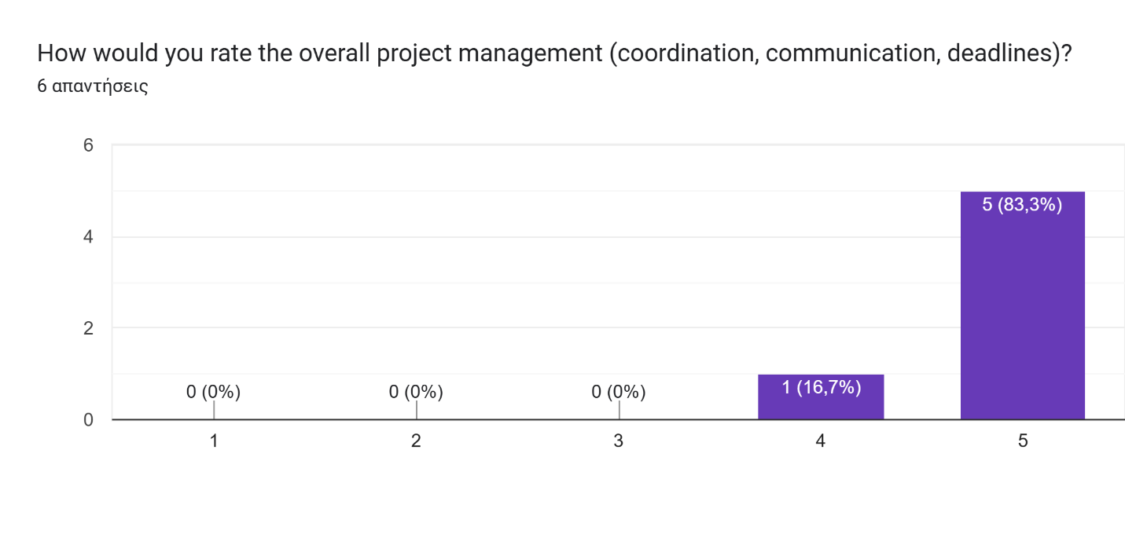
What worked well in project management?
- The team of organizers, led by the project manager, worked well. There was always communication, and the deadlines and specifics of what needed to be done were always clear.
- Whole activity of the groups and countries
- Communication was well structured and project coordinator Agata was always ready to help and gently reminded others to work by our schedule
- What worked well was the good teamwork and openness between partners. We always had quick communication, which made it easy to solve small problems right away. I also liked that the project management style gave us freedom to be creative, while still keeping everything organized. The supportive atmosphere made me feel comfortable to share ideas and take responsibility, and that really motivated me throughout the project.
- Common cooperation and communication, common decisions making
- The project management worked well because of the clear structure, defined roles, and constant communication among partners. From the beginning, responsibilities were transparent, which ensured smooth coordination. Regular online meetings and timely reporting helped us stay on track, while the trust and professionalism of the consortium allowed us to solve challenges quickly. The balance between flexibility and structured planning was a strong point, ensuring both quality implementation and adaptability.

What challenges did you notice in project management?
- Sometimes our deadlines slipped, but we managed to control it and worked together to tackle the tasks. We also sometimes redistributed the workload among partners and helped each other.
- its hard to open for new people sometime
- Sometimes we could miss some deadlines, but it's just a human thing and in those cases we just communicated and made everything possible to complete our tasks
- For me, the biggest challenge was the intensity of the timeline. At times it felt like there were many tasks happening at once, which made it difficult to keep the same energy in all activities. Another challenge was that not all partners used the same digital tools, so sometimes communication took longer than expected. Still, I think we managed well by supporting each other and being flexible.
- Not equal engeement from all persons involved in management
- The main challenges in project management were related to balancing diverse working styles across partners and ensuring that deadlines were respected without compromising quality. Coordinating different time zones, administrative procedures, and expectations sometimes required additional effort. Another challenge was maintaining equal levels of engagement in dissemination and follow-up activities, as some partners were stronger in these areas than others. However, these challenges also offered learning opportunities and reinforced the need for clearer monitoring tools.
Activity 2: Dissemination and Follow-Up Activities
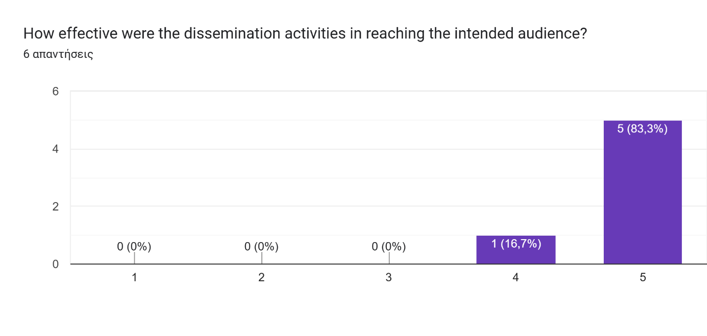
What was the impact of follow-up activities in your community/organization?
- For the organization, this means using new methods, engaging youth, and enhancing the expertise of youth workers
- people quickly became eager to continue working in the field of art therapy and wanted to explore further
- After the project we implied those art therapy methods into our clubs. For example it helped our theatre club and mental health club and adult community club, because their leaders organised such workshops for their communities many times after the project
- The follow-up activities really helped us bring the project closer to our community. Many young people who could not join the international trainings still got the chance to try the creative methods in our local workshops. This made them feel included and gave them new tools for self-expression. For me, it was also inspiring to see how local participants shared their experiences on social media, spreading the project’s message even further.
- People got to know what erasmus is and how they can use arts in their work with youngsters
- The follow-up activities had a strong impact on our community and organization. By organizing 12 local workshops, we managed to multiply the knowledge gained at the international level and transfer it directly to young people and youth workers. This created a ripple effect, where new methods were integrated into our daily youth work. It also increased our organization’s visibility and credibility at local level, positioning us as a reference point for using arts and creativity as non-formal education tools.

Activity 3: Checking Up and Evaluating the Learning Processes
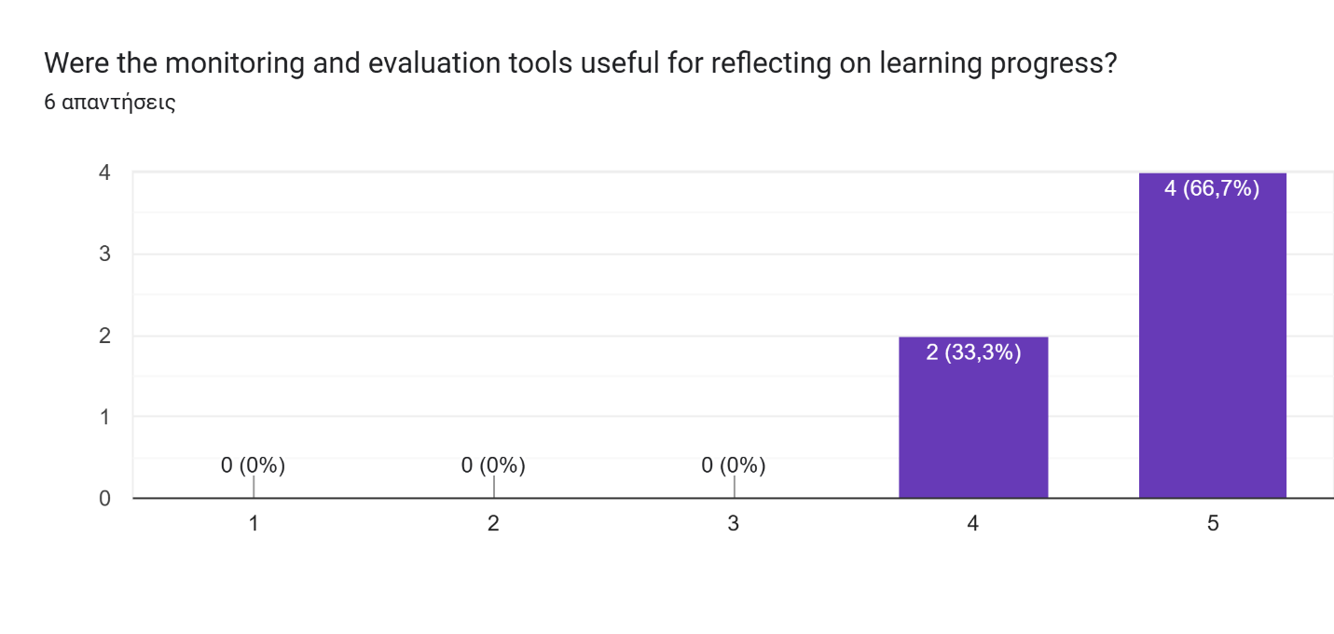
How did the evaluation of learning processes help you in your personal or professional growth?
- Evaluation after each stage of the project helped us react and understand what is working and which aspects need to be changed. Overall, assessing the project, we see that this direction and work with the model in art therapy are very important and necessary
- I feel more motivated
- It helped me a lot, because as a youth worker I need to educate myself on useful youth work methods and their impact on communities
- For me, the evaluation process helped me see my own progress and understand better how I support others in their learning. It gave me confidence to recognize what I am doing well and also where I can improve as a youth worker. Professionally, it showed me how to use simple tools to track learning outcomes and give useful feedback. This experience will help me plan future activities with more focus on the participants’ needs.
- I could see how i was at the begining and how participants were at the begining and how they are after the project
- The evaluation of the learning processes was very valuable for me as it provided a structured way to measure the effectiveness of our methodologies. Personally, it allowed me to reflect on how youth engage with creative and non-formal methods, and professionally it strengthened my ability to design programs with clearer learning outcomes. By analyzing feedback and progress, I could adapt my mentoring style and ensure that our organization continues to improve the quality and impact of its educational activities.
Activity 4: Kick Off TM Meeting (Poland)
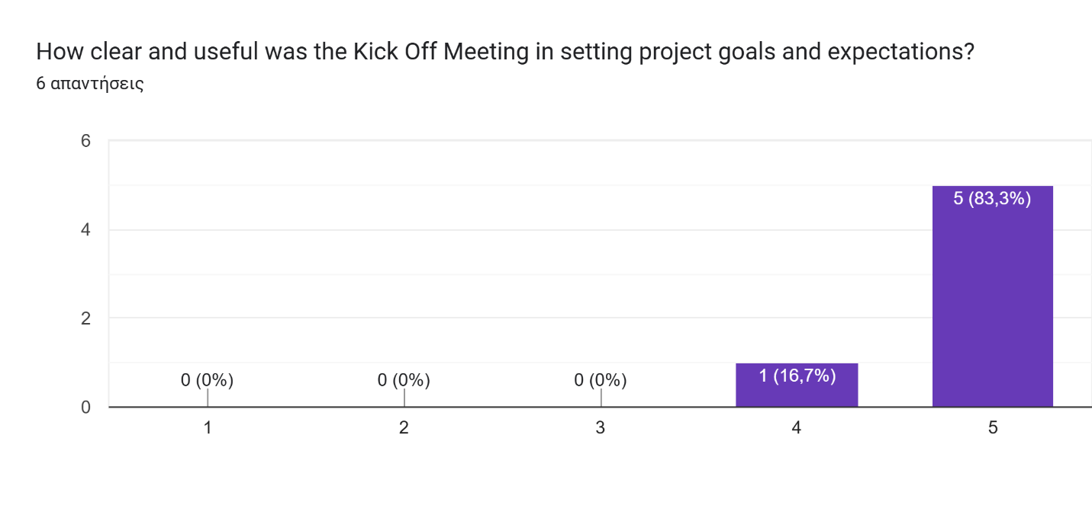
What could be improved in organizing initial transnational meetings?
- It was Great.
- i dont think there is something to improved
- I'm okay with everything:)
- The first meeting worked really well because we all got the information we needed and knew what to do next. If I think of an improvement, I would suggest adding more interactive sessions, like team-building activities or short workshops, so we can get to know each other’s working styles faster. That would make the cooperation even smoother and create a stronger team spirit from the beginning.
- all went good
- The initial transnational meeting was well organized and gave us all the necessary information to start the project confidently. What could be improved in the future is dedicating more time to discussing risk management and long-term sustainability during this first meeting. This would help us not only align on immediate tasks but also anticipate possible challenges and secure a stronger vision for the follow-up phase. More structured time for sharing each partner’s previous experiences could also strengthen the common understanding.

Activity 5: Initial Research (all countries)
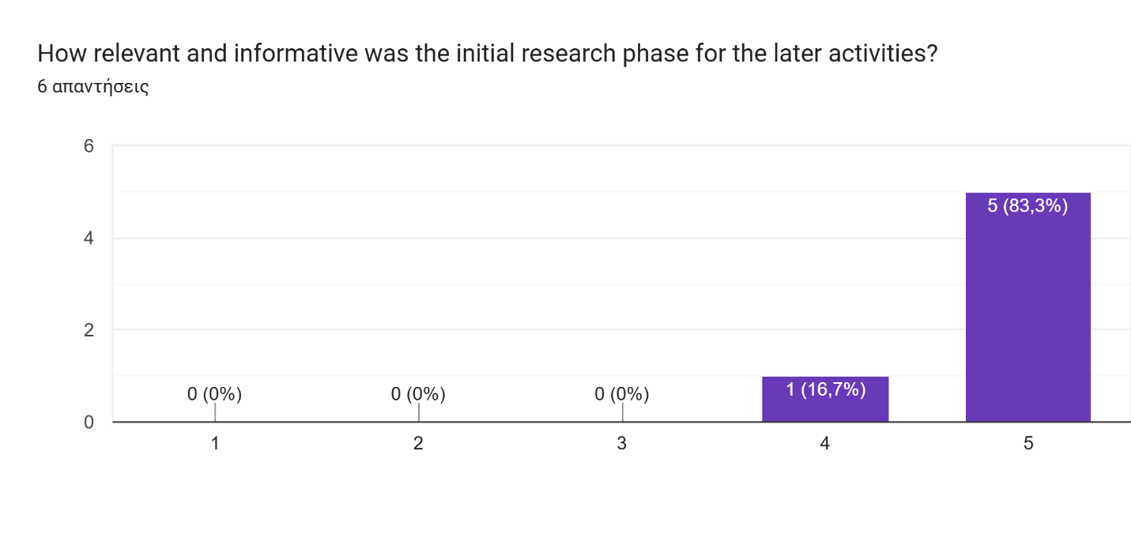
How well was the research integrated into the project’s next steps?
- The research results were very well implemented and realized for our participants within the project, as they directly corresponded to the initial objectives set for the project
- it went well and interesting becouse people are more into non formal education i this times
- As long as we created that project for our participants - every step of the project was very important, because it will affect our work And therefore it's a research, we were really careful to make it relevant
- Everything we learned from the research was really useful for what came next. It helped us understand better what young people need and what methods work best for them. I could see how the results influenced the activities we organized, making them more relevant and effective. For me, it was exciting to connect the research with the practical workshops and to see participants benefit from the knowledge we had collected.
- it was very well integrated it was also very necessary so involved persons understood the topic better
- The research was well integrated into the next steps of the project. All the findings were carefully analyzed and used to shape the design of the trainings and local activities. This ensured that our methods responded directly to the real needs identified in the research phase. For me, it was important to see that the data did not remain theoretical but became the foundation for practical tools, resources, and strategies that enriched the quality of our work and maximized impact.
Activity 6: Training of Youth Workers for Movement, Drama and Arts as Therapy (Cyprus)
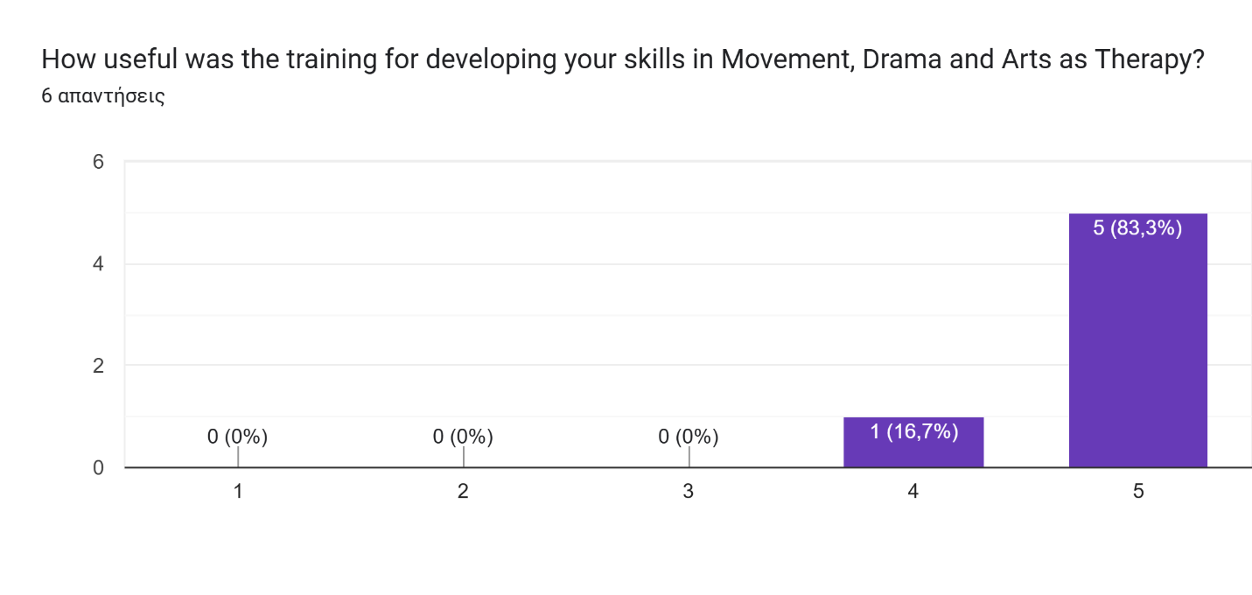

Which training methods or sessions were most effective?
- All of them - drāma, music, art, photography - because we use them in next Youth work
- I think mask therapy has the best impact on feelings
- Trainings in Cyprus and Latvia, because it mostly was about useful methods we could use in youth work and we actually used those:)
- For me, the most effective sessions were the interactive and hands-on ones. I especially remember the art-based workshops where we used painting, theater, and movement to explore emotions and teamwork. They were fun, creative, and at the same time very powerful for learning. I also found the group reflection circles very useful because they helped us share experiences and learn from each other. These methods made the training lively and kept everyone engaged.
- All were very effective as it was all realted to NFE methods
- During the first training in Cyprus, the most effective sessions were those combining theory with practice. For example, the workshops on using creative arts as non-formal education tools stood out, as they allowed participants not only to understand the methodology but to immediately apply it in group activities. The reflective sessions, where participants linked creative practices with inclusion and empowerment, were also very impactful. These methods ensured deep learning and provided practical tools that youth workers could easily transfer back to their communities.
What areas of the training could be strengthened?
- Everything was very useful for our Youth workers And organisation
- maybe more work outside somehow
- I liked all of the parts
- The training was great, but I think we could improve by giving a bit more time for open discussions after the workshops. Sometimes the schedule was very packed, and we moved quickly from one session to another. Also, adding more digital tools for sharing ideas could make it easier for participants to connect and keep track of what they learned. A little more focus on practical “ready-to-use” methods would also help youth workers when they go back to their local communities.
- all participants were very satisfied with the training, they have learnt new approach on how to use creative artvs in NFE
- The training was very successful, yet there are areas that could be strengthened in the future. I believe more structured time for evaluating each day’s learning outcomes would help participants consolidate their knowledge. Additionally, while the creative sessions were strong, a deeper focus on linking these artistic methods to long-term youth work strategies could provide added value. Finally, integrating more collaboration with local stakeholders during the training could enhance its relevance and community impact.
Activity 7: Implementation of Movement, Drama and Arts as Therapy
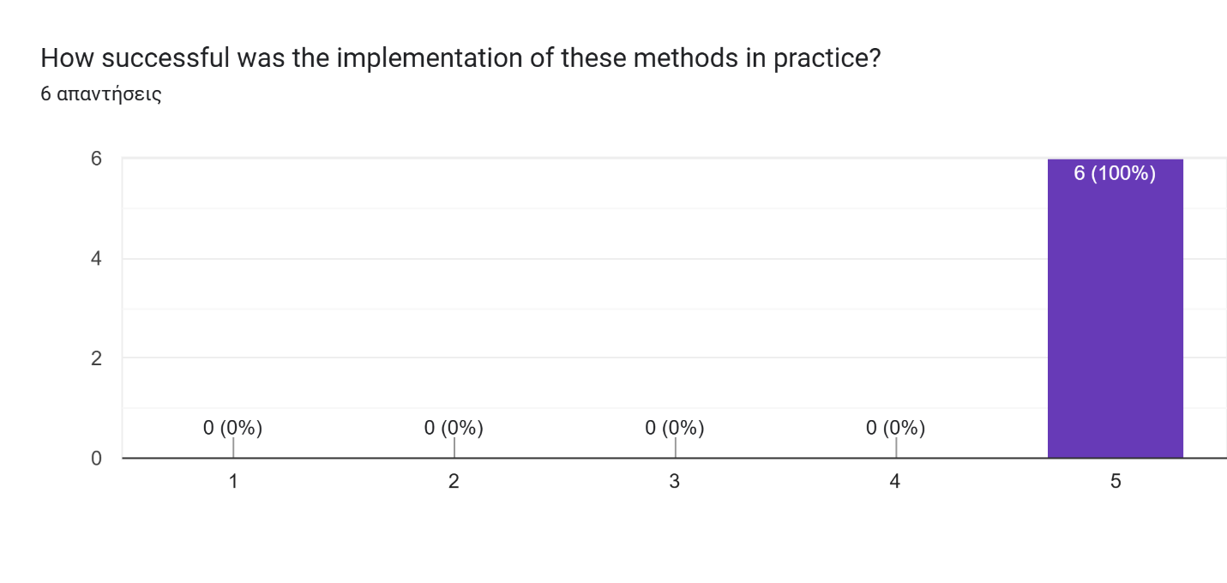
What impact did these activities have on the target groups (youth, community)?
- It was amazing, because our target group got all benefits from it - knowledges, Experts explanstoon And work, community development, inspiration for new ideas
- People saw that these were unusual teaching methods, so they were divided into those who were less interested and those who were interested, but this didn't prevent anyone from working and getting involved. Ultimately, the reception was positive.
- Positive impact of course:) Our youth liked the workshops and as community we will continue to use those in our job
- This activity had a really positive effect on the young people because it gave them a safe space to use art and movement to express themselves. Many participants said it helped them feel more confident and connected with others. For youth workers, the chance to test and adapt activities in real time was very useful, because they could see what worked best for their groups. The inclusion of volunteers from disadvantaged backgrounds was also important, since it gave them opportunities to join and benefit from creative methods. Overall, the sessions helped both youth and facilitators grow, while the shared document kept everyone learning together.
- Youngsters have learnt that education can be interesting and not pushy as it is at schools
- The activity had a strong impact on both youth and the wider community. By integrating movement, drama, and arts as therapy, young people gained new tools for self-expression, emotional regulation, and teamwork. For youth workers, the activity created a structured process of reflection and adaptation, ensuring that methods were continuously improved to meet the needs of diverse groups. The involvement of disadvantaged youth was particularly valuable, as it fostered inclusion and empowerment. At community level, these sessions strengthened trust between youth workers and participants, while the preparation of a collective working document ensured that the results will have long-term sustainability and transferability.
Activity 8: Training of Trainers for Photography and Music as Therapy (Latvia)
Which elements of the training were most valuable for your work?
- All of them - we use it in our Youth work
- i think photowalk or part when we have to take picture of 3 elements and explaine why we picked them
- Network with people and of course the information we learned during the training (methods)
- The most valuable parts for me were the hands-on sessions where we created music and used photography to explore emotions. It gave me simple but powerful tools that I can bring into my workshops with young people. I also found it inspiring to see how combining music and art can help those who struggle to talk about their feelings. These sessions showed me very practical ways to connect with young people through creativity.
- Participants really liked how they have learnt how to perceive photogtaphy differently and how to use it to perceive themsleves
- The most valuable elements of this training were the structured exploration of music therapy techniques and their direct connection to youth work practices. Learning how to combine music with art and photography provided an interdisciplinary approach that enriches non-formal education methods. For me, the sessions highlighting the therapeutic value of self-expression and creativity were especially important, as they offered practical strategies for supporting young people facing stress, anxiety, or social exclusion. The training not only provided technical knowledge but also reinforced the idea that art and music can be used as sustainable tools for long-term personal development and social inclusion in our community programs.
What additional support or resources would have improved this training?
- Everything was perfect. Thank you
- i improve my emotional express
- Everything was okay
- The training was really good, but I think it would have been even better if we had more instruments and cameras to try out different methods. Also, having a shared online space with videos and ready-to-use activity plans would make it easier to apply everything back home. A short follow-up mentoring session after the training would also help us feel more supported when trying out these methods with our own groups.
- Maybe some additional tools for photorgraphy or training on editing photos to make it even more personal
- The training was very well designed, yet it could have been strengthened with additional resources such as expert input from professional music or art therapists to deepen the theoretical foundation. Access to more specialized equipment, for instance musical instruments or professional photography tools, would have allowed participants to explore advanced techniques. Finally, preparing a structured manual or toolkit during the training itself would help ensure that the methods can be easily transferred and adapted by youth workers in their local realities.

Activity 9: Implementation of Photography and Music as Therapy
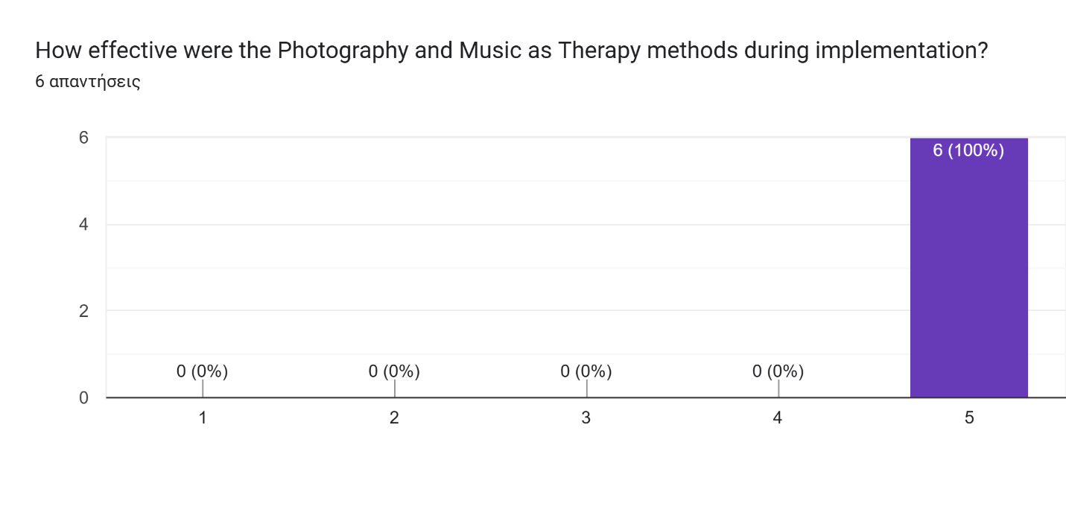
What feedback did you receive from participants involved in these activities?
- Everybody were satisfied
- They felt free of the picking objects to take photo and then they have no bariers to explaine why they picked them. They felt very familiar with activity, but they have never done this before
- They liked it so much that some of participants made workshops on those methods after the training
- The feedback was very positive. Many young people said that photography and music helped them express feelings they usually find hard to talk about. They liked the creative and relaxed atmosphere, and some even said it helped reduce their stress. Youth workers also shared that these methods gave them fresh ideas they could adapt to their own groups. The main suggestion was to use even more tools and time for practice.
- Participants loved it, they sadi they have never participated in something similar
- The feedback we received from participants during the implementation of photography and music as therapy was very encouraging. Many youth workers highlighted that these tools provided new, creative ways to connect with their groups, especially with young people who often struggle to express themselves verbally. Participants appreciated the flexibility of the methods, noting that the activities could be easily adapted to different group dynamics and individual needs. The involvement of volunteers from disadvantaged backgrounds was also highly valued, as it made the process more inclusive and gave them an opportunity to engage in meaningful self-expression. Constructive feedback pointed to the importance of having more technical resources (such as instruments or cameras) and further guidance on structuring sessions. Overall, participants confirmed that these activities enhanced their professional toolkit and strengthened the impact they can have in their local communities.
Activity 10: Handbook, Video, and Cards (Outputs)
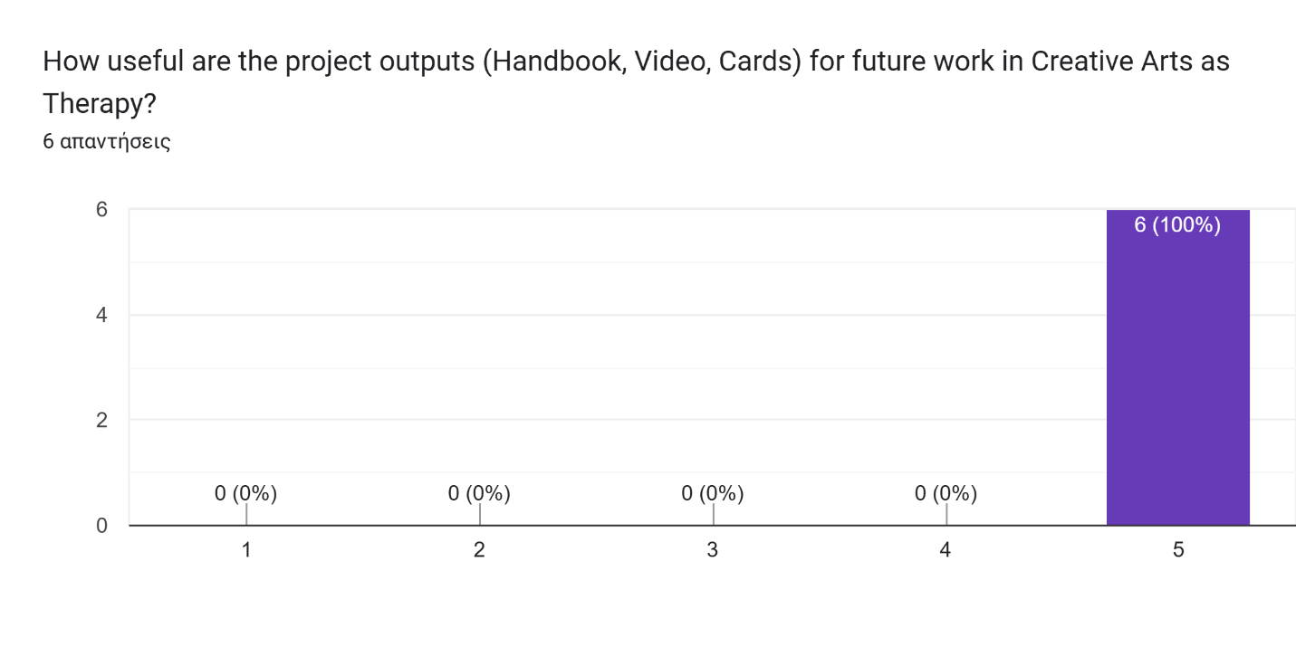
Which output do you find most practical and why?
- With the cards, because we will use them for working with youngsters in youth office.
- Cards beacouse they are easy to explaine and simple to do with diffrent age of people
- We put the link with handbook and video tutorials to our Instagram page, so everyone can find it and learn And we are really happy when people use this opportunity to educate themselves on youth work methods I personally think that cards is a really cool output, because it's physical
- For me, the most practical output is the cards, because they are easy to use in any session and can quickly engage participants. They make activities more interactive and fun, while still carrying deep meaning. I also find the videos useful, especially for inspiring others and showing real examples of the methods in action. The Handbook is great for background knowledge, but the cards are something I can take with me and use right away in workshops.
- I think the most practical is Handbook as it gathers all the tools all together and are easy to use
- From my perspective, the most practical output is the Handbook, as it provides a structured and comprehensive guide that youth workers can directly apply in their daily practice. It brings together all the methods, reflections, and adaptations tested throughout the project, offering a reliable reference point for both new and experienced trainers. While the videos and cards are excellent complementary tools that make the activities more engaging and accessible, the Handbook ensures continuity and sustainability. It allows us to integrate Creative Arts as Therapy into long-term strategies, and it will remain a valuable resource for training new staff and supporting organizations that want to adopt these approaches in the future.
Activity 11: Final TM Meeting (Poland)
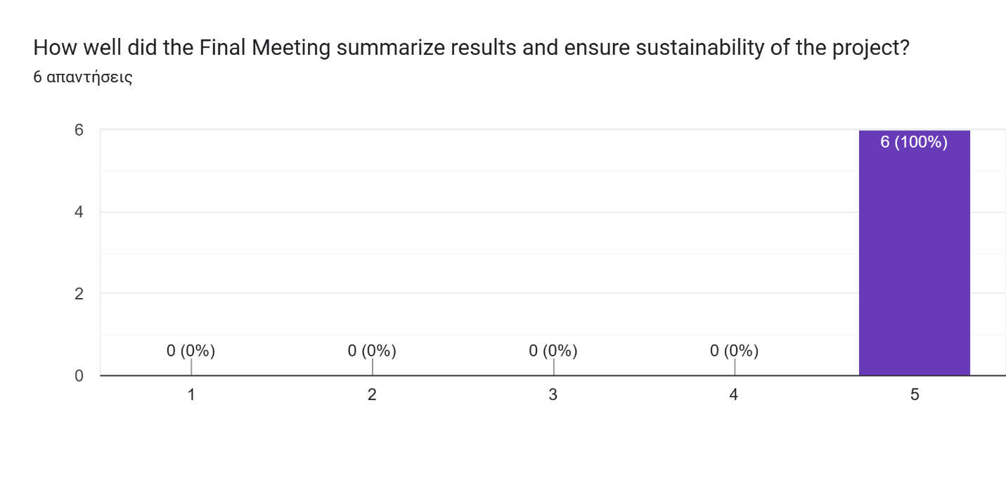
What improvements could be made for future final meetings?
- Thank for hospitality ❤️
- i dont have one
- None, everything was fine for me
- I think the final meeting could be improved by adding more space for creative sharing between partners, like mini-workshops where we show each other our favorite activities. Also, having a more informal session to celebrate achievements together would make the ending feel warmer and more connected. Another idea is to include more young people or community members in the final presentation, so they can also share how the project influenced them.
- The whole meeting went very well and smoothly and all were satisfied
- The final meeting was a very productive space for reflection and closure; however, several improvements could strengthen future editions. Firstly, dedicating more structured time for participants to present their local follow-up results would allow us to exchange practical insights more deeply. Secondly, involving external stakeholders such as local policymakers, educators, or community representatives could enhance the visibility and long-term impact of the outcomes. Additionally, a stronger focus on planning sustainability—by clearly outlining how each partner will continue using the outputs—would ensure continuity beyond the project’s lifetime. Finally, including more interactive and creative elements during the final meeting could help maintain the same energy and spirit that characterized the main activities.

Final Reflection
What is your key takeaway from this project?
- We have new methods and handbook, also we want to develops this topic, so will continue to work on it.
- everyone looks at reality differently and emotionally perceives their work and what is happening around them differently
- Network:))))) I'm grateful for meeting those cool people And of course our creative outputs because it affected the community
- My key takeaway is that art and creativity are not just fun activities—they are powerful tools that help young people feel safe, open up, and grow. I learned how important it is to adapt methods to each group’s energy and needs, and how small creative steps can make a big difference in building confidence and inclusion. Personally, I also feel more confident as a youth worker after testing and leading these methods.
- Skills that i have get form learning project management and the change in participants
- My key takeaway from this project is the confirmation that creative arts can be powerful tools for youth empowerment, emotional well-being, and social inclusion when integrated into non-formal education. The combination of music, photography, drama, and movement provided youth workers with innovative methods that can be adapted to different contexts and communities. For me, the greatest value lies in seeing how these tools not only enhanced professional practice but also created safe spaces where young people could express themselves freely, build confidence, and strengthen connections. This project demonstrated the long-term potential of creative arts as therapy in youth work and inspired me to continue promoting their use at both local and European levels.
Would you recommend similar projects to colleagues or partner organizations?
- Yes, 100%
- Of course i would, its very important to educate people with that kin of work
- YESSSSS DEFINITELY
- Yes, definitely. This kind of project gives youth workers new methods, confidence, and motivation to bring more creativity into their work. I would recommend it to colleagues who want to connect better with young people and support their well-being in innovative ways. It also builds strong networks between organizations, which makes future cooperation much easier and more exciting.
- of course, such a project was a great deveolpment for both personal growth and organisational growth. It was amazing time and it is hard to believe that 2 years have passed so fast.
- Yes, I would strongly recommend similar projects to colleagues and partner organizations. This initiative clearly demonstrated the added value of combining creative arts with non-formal education, offering both youth workers and young people innovative methods to address emotional well-being, inclusion, and empowerment. The practical tools developed—such as the Handbook, videos, and cards—ensure that the impact goes beyond the project itself and can be easily replicated in different contexts. Such projects strengthen cooperation at European level, enrich professional practice, and provide long-term benefits for communities.

